**SHRI VAISHNAV VIDHYAPEETH VISHWAVIDYALAYA, INDORE (M.P.)**



A Minor Project Report on

**Smart Billing Cart**

In Partial Fulfillment of the Degree of

**BACHELOR OF TECHNOLOGY**

**In**

**ELECTRONICS & COMMUNICATION ENGINEERING (IOT)**

**Submitted by-**

**Anshul Agrawal (18010BTEC03571)**

**Under the guidance of**

**Mr. Shiraz Husain**

**(Assistant Professor)**

**DEPARTMENT OF ELECTRONICS ENGINEERING**

**SHRI VAISHNAV INSTITUTE OF TECHNOLOGY& SCIENCE, INDORE**

**SHRI VAISHNAV INSTITUTE OF TECHNOLOGY& SCIENCE, INDORE**

**DEPARTMENT OF ELECTRONICS ENGINEERING**



**CERTIFICATE**

This is certified that the project entitled “**SMART BILLING CART”** is the record of bona fide work done by **Anshul Agrawal (18010BTEC03571)** under my guidance for the partialfulfillment of the requirements for the award of the degree of **Bachelor of Technology** in **Electronics & Communication (IOT).** To the best of my knowledge, this project is an original work done by the students in order to learn the fundamentals of engineering and design.

Date:- Date:-

___________________ ___________________

(Internal Examiner) (External Examiner)

**ACKNOWLEDGEMENT**

We would like to take this opportunity to express our extreme gratitude towards our project guide **Mr. Shiraz Husain** Assistant Professor, Department of Electronics Engineering for his/ her invaluable guidance, advice and support throughout the project. His/ Her motivation and help have been a source of great inspiration to us.

We are also grateful to our & Project Coordinator **Mr. Ravindra Sharma,** Associate Professor in our department providing us adequate facilities because of which my project has been successful.

We are very indebted to **Dr. NAMIT GUPTA(HOD), Director SVITS** who motivated us to improve the quality of our project and extended all supports required at institution level.

Last but not the least we are also thankful to all faculty & staff members of our department for corporation extended in completion of our project

**INDEX**

ContentPage No.

* 1. **Abstract 5**
  2. **Introduction 6**
  3. **Problem statement 7**
  4. **Hardware specifications 9**
  5. **Application 13**
  6. **Block diagram 14**
  7. **Schematic Design 15**
  8. **PCB Layout 16**
  9. **Working 18**
  10. **Future Scope 23**
  11. **Conclusion 24**

**1.Abstract**

Nowadays, buying and searching at huge malls is turning into a daily activity in subway cities. We can see large rush at malls on holidays and weekends. The rush is even a lot of once there are special offers and discount. People purchase totally different things and place them in trolley. After total purchase one needs to go to cashier for payments. The cashier prepare the bill victimization bar code reader that could be a time overwhelming method and leads to long queues at charge counters. This paper targeted to minimize the Queue at a billing counter in a shopping complex. Smart Trolley does the same by displaying the total price of the product kept inside the cart. In this way the customer can directly pay the amount at the billing counter and leave with the commodities he/she has bought. The hardware is based on Arduino Uno, RFID Reader Module, RFID Card and Buzzer. It eliminates the traditional scanning of products at the counter and in turn speeds up the entire process of shopping, also with this system the customer shall know the total amount to be paid and hence can accordingly plan his shopping only buying the essential commodities resulting in enhanced savings. Since the entire process of billing is automated it reduces the possibility of human error substantially. Also the system has a feature to delete the scanned products by customer to further optimize the shopping experience.

**2.Introduction**

Shopping mall is a place where most people from all walks of life will get their daily necessities ranging from food product, apparels, toiletries, gardening tools electrical appliances, and others. The numbers of little and enormous looking malls keep it up increasing over the years throughout the world because of the demand of the general public. Thus, the amount of advancement of shopping center system and infrastructure conjointly varies. Compared to some foreign countries’ shopping mall system, there are still a plenty of spaces for improvement in terms of providing quality shopping experience to the consumers. Consumers often face many problems and inconvenience when shopping. These problems include worrying that the amount of money brought is not enough for paying all the items needed, insufficient information of the items that are for sale and also wasting time at the cashier. These are the issues that include worrying that the amount of money brought is not enough for paying all the items needed, insufficient information of the items that are for sale and also wasting time at the cashier. These are the issues faced by the customer. There are some existing ways to resolve the issues that are declared on top of however the effectiveness still take into account corrigible. Examples of existing downside finding techniques are subbing the traditional approach of keying item per item by hand to the register with the technology of barcode scanning wherever the cost are stored in the barcode, and also set up a client information counter to help the client if there are any enquiries about the items at shopping mall.

**3.Problem statement**

**3.1 EXISTING SYSTEM**

The currently available method in shopping malls is barcode method. In this technique there are barcode labels on every product which might be browse through specially designed barcode readers. A barcode reader is Associate in electronic device for reading written barcodes. Like a flatbed scanner, it consists of a lightweight supply, a lens and a light sensor translating optical impulses into electrical ones. Additionally, nearly all barcode readers contain decoder circuitry analyzing the barcode's image data provided by the sensor and sending the barcode's content to the scanner's output port. When we have a tendency to choose any product for purchasing we place it within the trolley and take it to the cashier. The cashier scans the merchandise through the barcode scanner and offers North American country the bill. But this becomes a slow method once ton of merchandise is to be scanned, therefore creating the billing method slow. This eventually results in long queues.

**3.2 PROPOSED SYSTEM**

Radio Frequency Identification (RFID) is changing into preferred technology as another to barcode systems. RFID systems gives automatic identification method, counting on storing remotely retrieving knowledge mistreatment RFID tags or transponders. An RFID tag is associate object that may be connected to or incorporated into a product, animal, or person for the aim of identification mistreatment radio waves. Chip-based RFID tags contain silicon chips and antennae. In this paper, we have developed a smart shopping cart system that allows customers to manage their shopping list while shopping and only pay the bill at the checkout counter. The cart has the power to calculate mechanically and show the entire costs of all the product within it. This makes it simple for the client to understand what quantity he or she has got to pay whereas searching and not at the checkout. This way the client will receive quicker service at the checkout. The advantage for the shop owners is that they'd would like fewer cashiers, which might end in an outsized cut in their prices.

**3.3 Why Rfid?**

Radio-frequency identification (RFID) may be a technology that uses radio waves to transfer information from associate electronic tag, known as RFID tag or label, connected to associate object, through a reader for the purpose of identifying and tracking the object. RFID Tag may be a special sort wireless card that has built-in the embedded chip alongside loop antenna. The built-in embedded chip represents the twelve digit card variety. RFID reader is that the circuit that generates 125KHZ magnetic signal. This magnetic signal is transmitted by the loop antenna connected alongside this circuit that is employed to scan the RFID card variety. In this project RFID card is employed as security access card. So every product has the individual RFID card that represents the merchandise name. RFID reader is interfaced with microcontroller. Here the microcontroller is that the flash sort reprogrammable microcontroller within which we tend to already programmed with card variety.

Some major applications of RFID:

1. Access control (keyless entry)

2. Asset tracking (self check-in and self check-out)

3. Asset tagging and identification (inventory and shelving)

4. Authentication (counterfeit prevention)

5. Point-of-sale (POS) (Fast Track)

**4. Hardware requirements**

* 1. **Power supply**: A **power supply** is an **electrical** device that **supplies** electric **power** to an **electrical** load. The primary function of a **power supply** is to convert electric current from a source to the correct voltage, current, and frequency to **power** the load. The Entire Project needs power. However, from the study of this project it comes to know that we supposed to design power supplies 5V,1A.
  2. **RFID Reader Module**: EM-18 RFID scanner module uses a RFID reader which will read a hundred twenty five kilohertz tags. So, it will be known as a low frequency RFID reader. It offers out a serial output and contains a range of regarding 8- 12 cm. There is a inbuilt antenna and it are often connected to the laptop with the assistance of RS232. RFID Reader Module, are also called as interrogators. They convert radio waves returned from the RFID tag into a type which will be passed on to Controllers, which can make use of it. RFID tags and readers need to be tuned to a similar frequency so as to communication

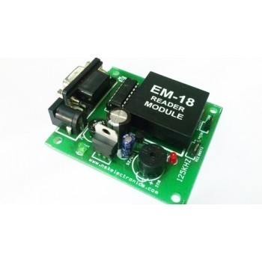

* 1. **LCD Display:** LCD (Liquid Crystal Display) screen is an electronic display module and notice a wide vary of applications. A 16x2 display is extremely basic module and is extremely ordinarily utilized in various devices and circuits. These modules are most well-liked over seven phases and different multi segment LEDs. The reasons being: LCDs are economical; simply programmable; haven't any limitation of displaying special & even custom characters (unlike in seven segments), animations and then on. A 16x2 LCD means it can display 16 characters per line and there are 2 such lines. In this digital display every character is displayed in 5x7 picture element matrix. This digital display has 2 registers, namely, Command and information.

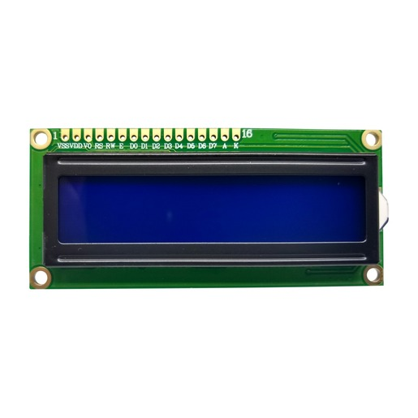

* 1. **RFID Card** **:** A radio frequency identification reader (RFID reader) is a device accustomed gather data from an RFID tag that is employed to trace individual objects .Radio waves are accustomed transfer knowledge from the tag to a reader. RFID may be a technology similar in theory to bar codes. However, the RFID tag doesn't got to be scanned directly, nor will it need line-of-sight to a reader. The RFID tag it should be among the vary of an RFID reader, that ranges from three to three hundred feet, so as to be scan. RFID technology permits many things to be quickly scanned and permits quick identification of a specific product, even once it's encircled by many different things. RFID tags have not replaced bar codes due to their price and the need to singly determine each item

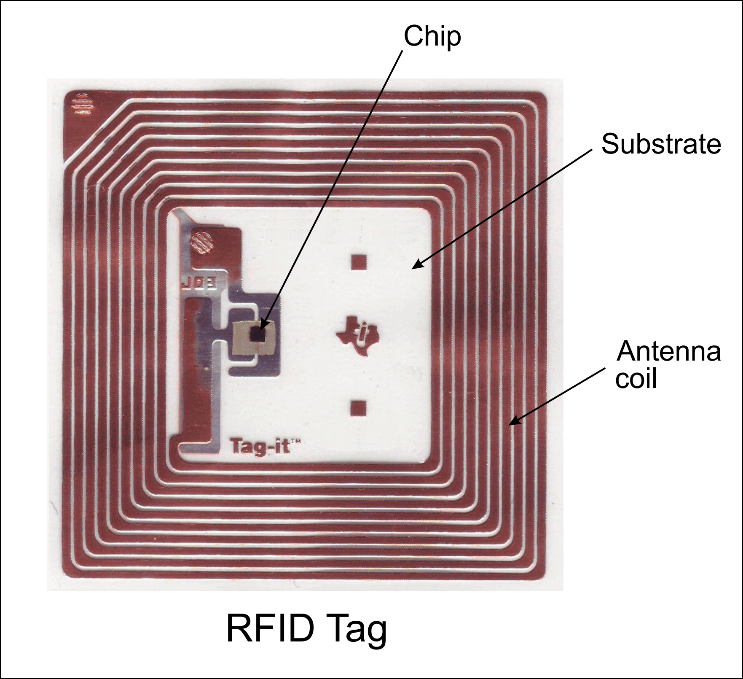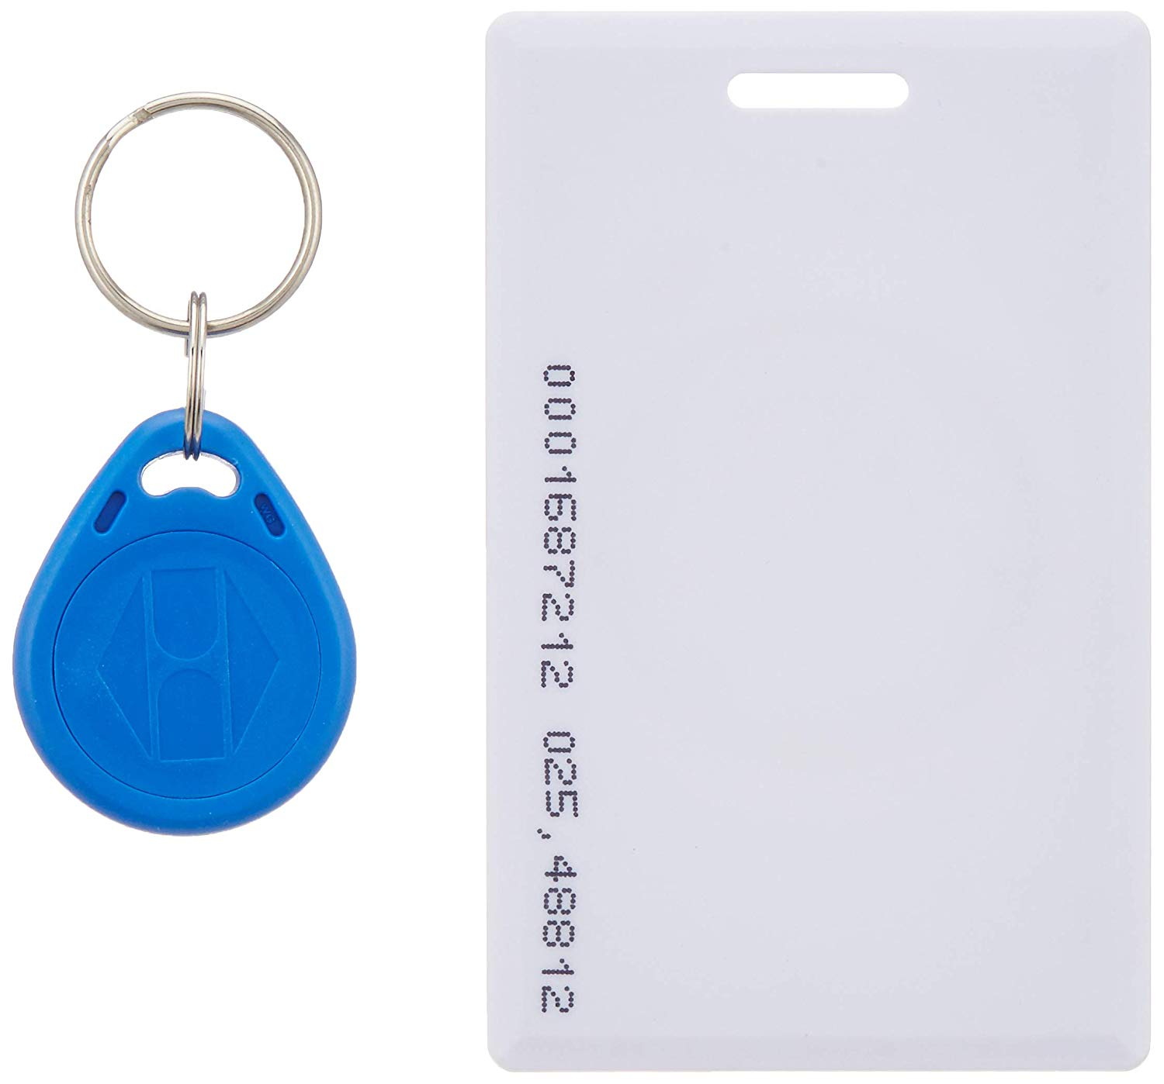

**4.5 Arduino**: Arduino is an open-source platform used for building electronics projects. Arduino consists of both a physical programmable circuit board (often referred to as a microcontroller) and a piece of software, or IDE (Integrated Development Environment) that runs on your computer, used to write and upload computer code to the physical board . The Arduino platform has become quite popular with people just starting out with electronics, and for good reason. Unlike most previous programmable circuit boards, the Arduino does not need a separate piece of hardware (called a programmer) in order to load new code onto the board – you can simply use a USB cable. Additionally, the Arduino IDE uses a simplified version of C++, making it easier to learn to program

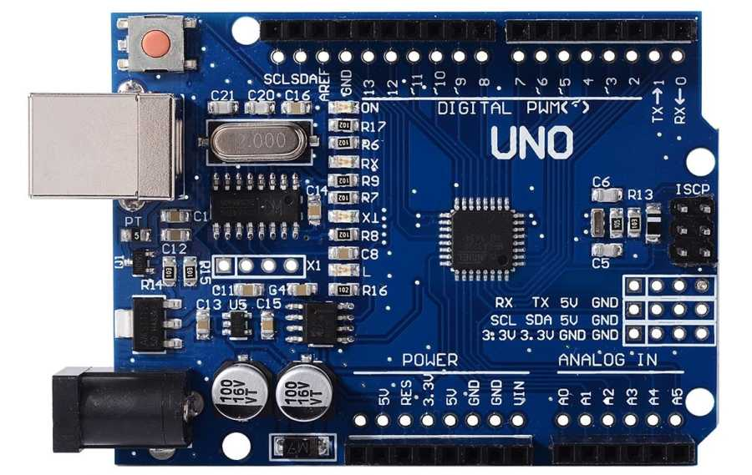

**4.6 Buzzer** :a buzzer or beeper is an [audio](https://en.wikipedia.org/wiki/Sound) signaling device,[[1]](https://en.wikipedia.org/wiki/Buzzer#cite_note-1) which may be [mechanical](https://en.wikipedia.org/wiki/Machine), [electromechanical](https://en.wikipedia.org/wiki/Electromechanics), or [piezoelectric](https://en.wikipedia.org/wiki/Piezoelectricity) (piezo for short). Typical uses of buzzers and beepers include [alarm devices](https://en.wikipedia.org/wiki/Alarm_devices), [timers](https://en.wikipedia.org/wiki/Timer), and confirmation of user input such as a mouse click or keystroke.

**4.7 Copper Clad PCB :- Copper Clad** Laminate, abbreviated to CCL, is a type of base material of **PCBs**. With glass fiber or wood pulp paper as reinforcing material, a CCL is a type of product through lamination with **copper clad** on either one side or both sides of reinforcing material after being soaked in resin.

**4.8 Software used:**

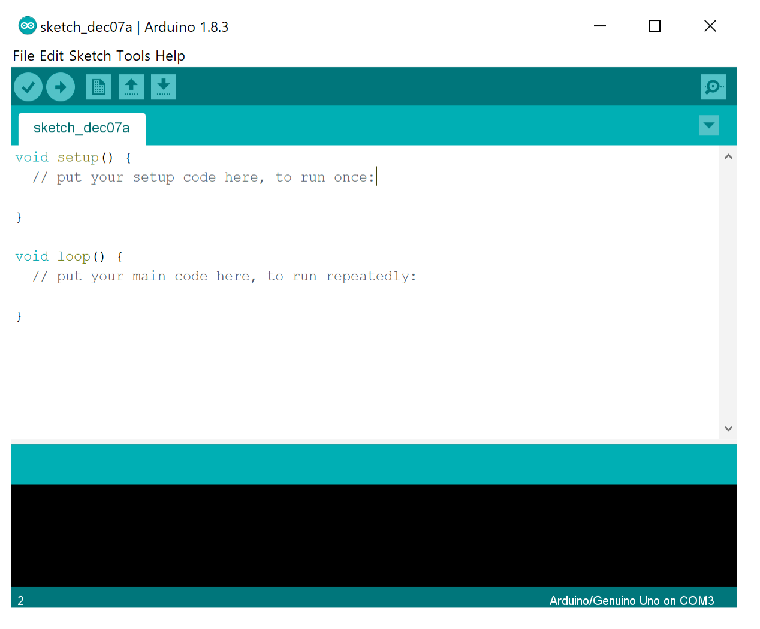

**5.APPLICATIONS OF AUTOMATIC BILLING CART**

This device can be used in various places such as-

a. Super Markets

b. Shopping centre

c. Grocery Shops

**6.Block diagram**

Power Supply

Arduino UNO R3

board

LCD Display (16x2)

RFId Tag

RFId Reader

RFId Tag

LCD Display (16x2)

Buzzer

Switch

Buzzer

**7.Schematic diagram**

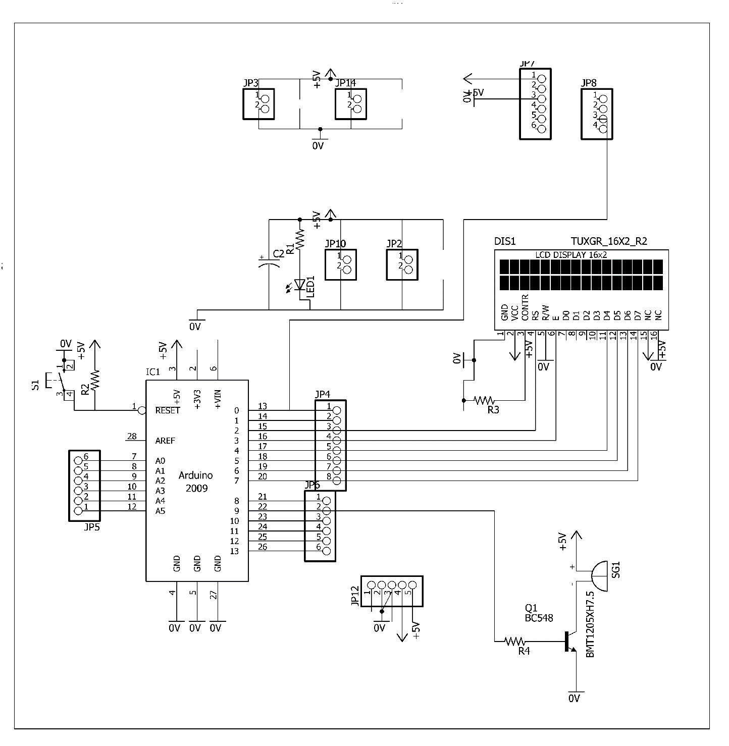

**8.PCB Layout**

**8.1 Layout with component**

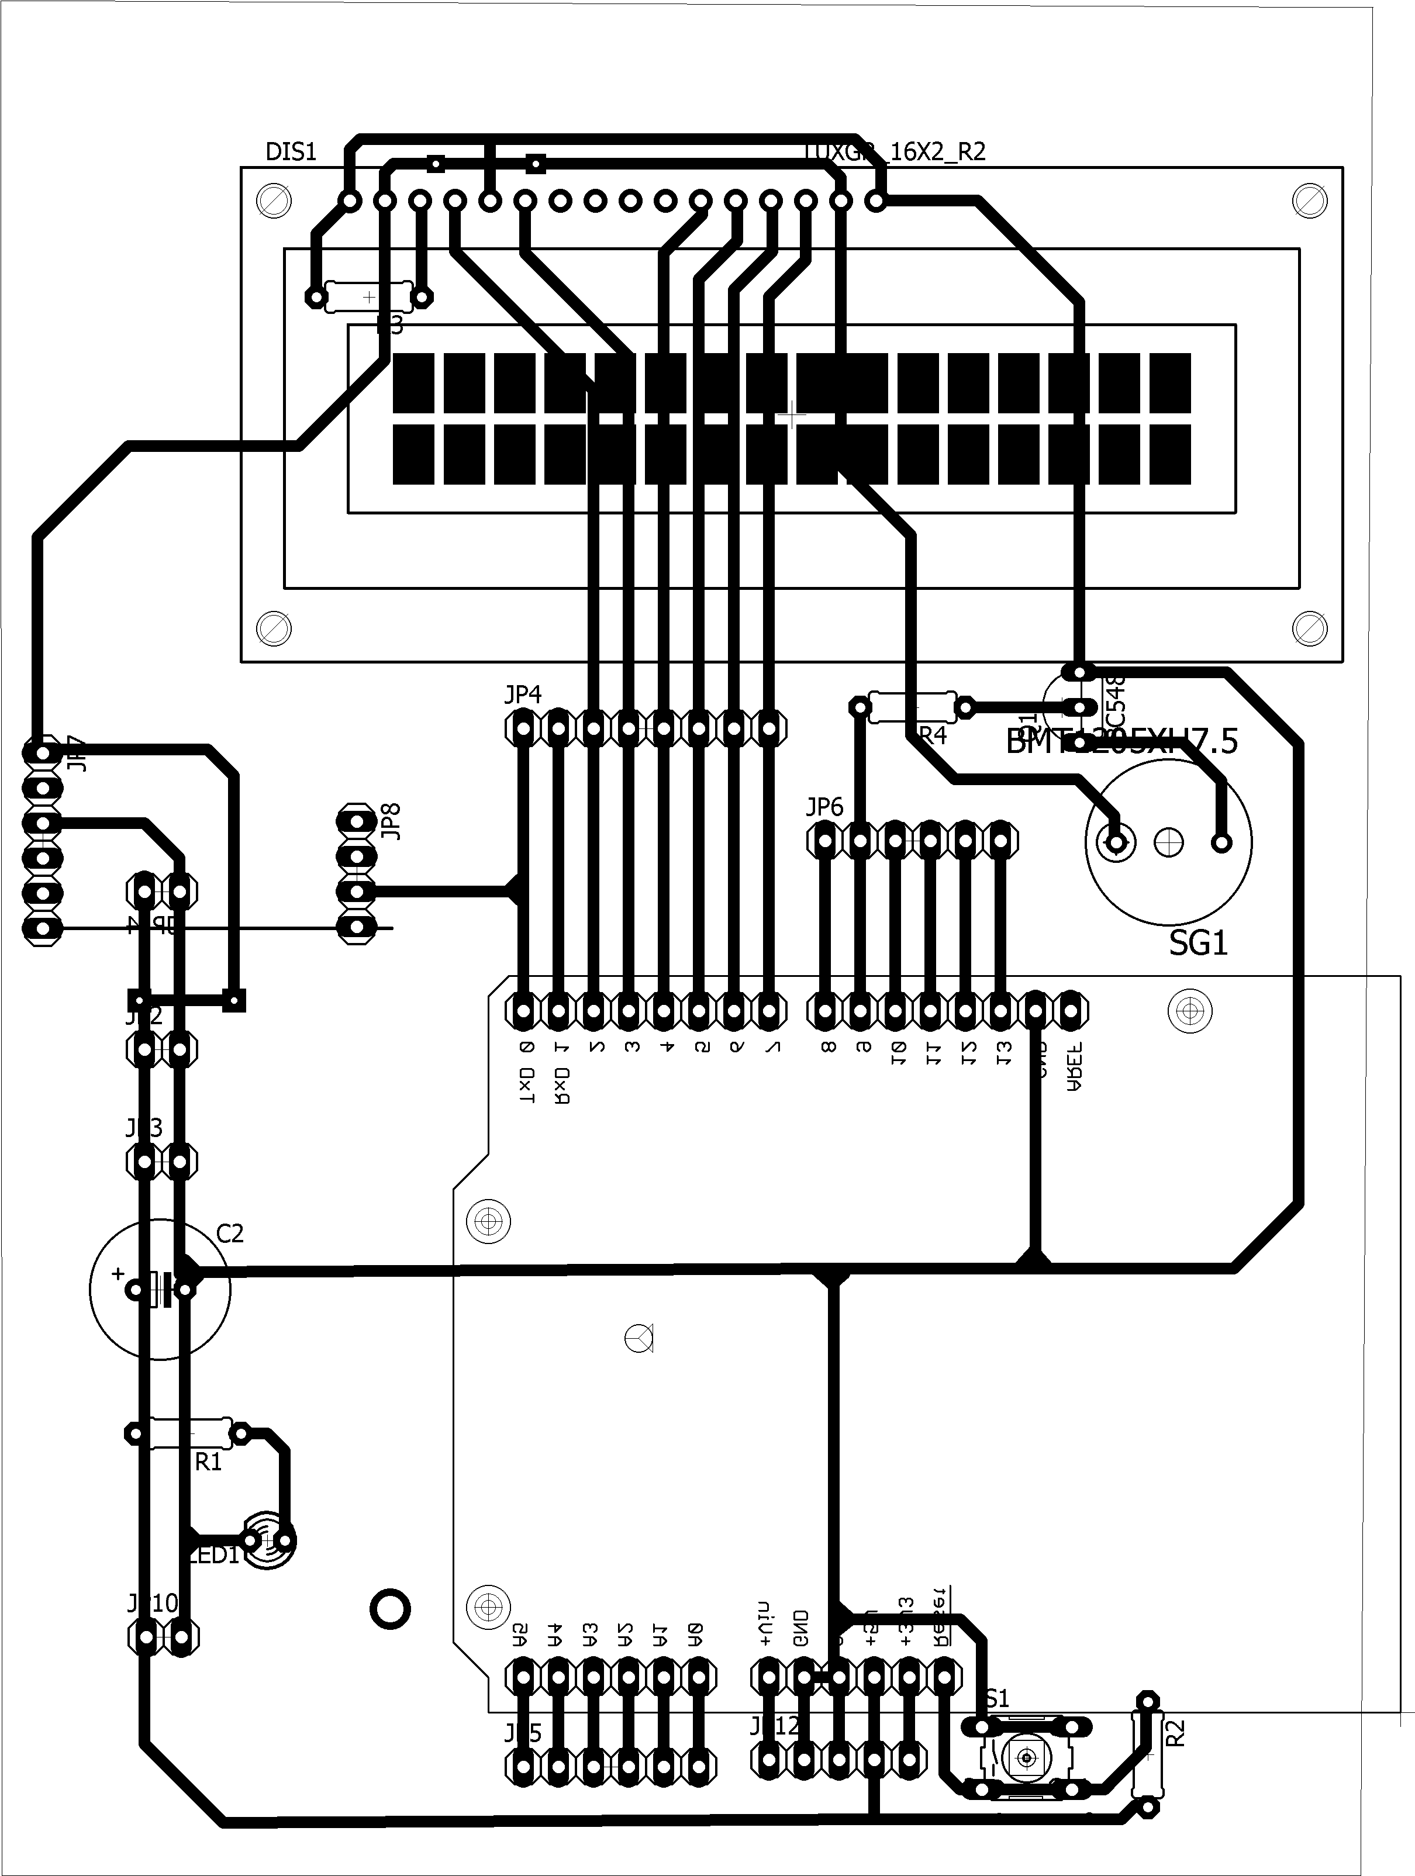

**8.2 Layout with print**

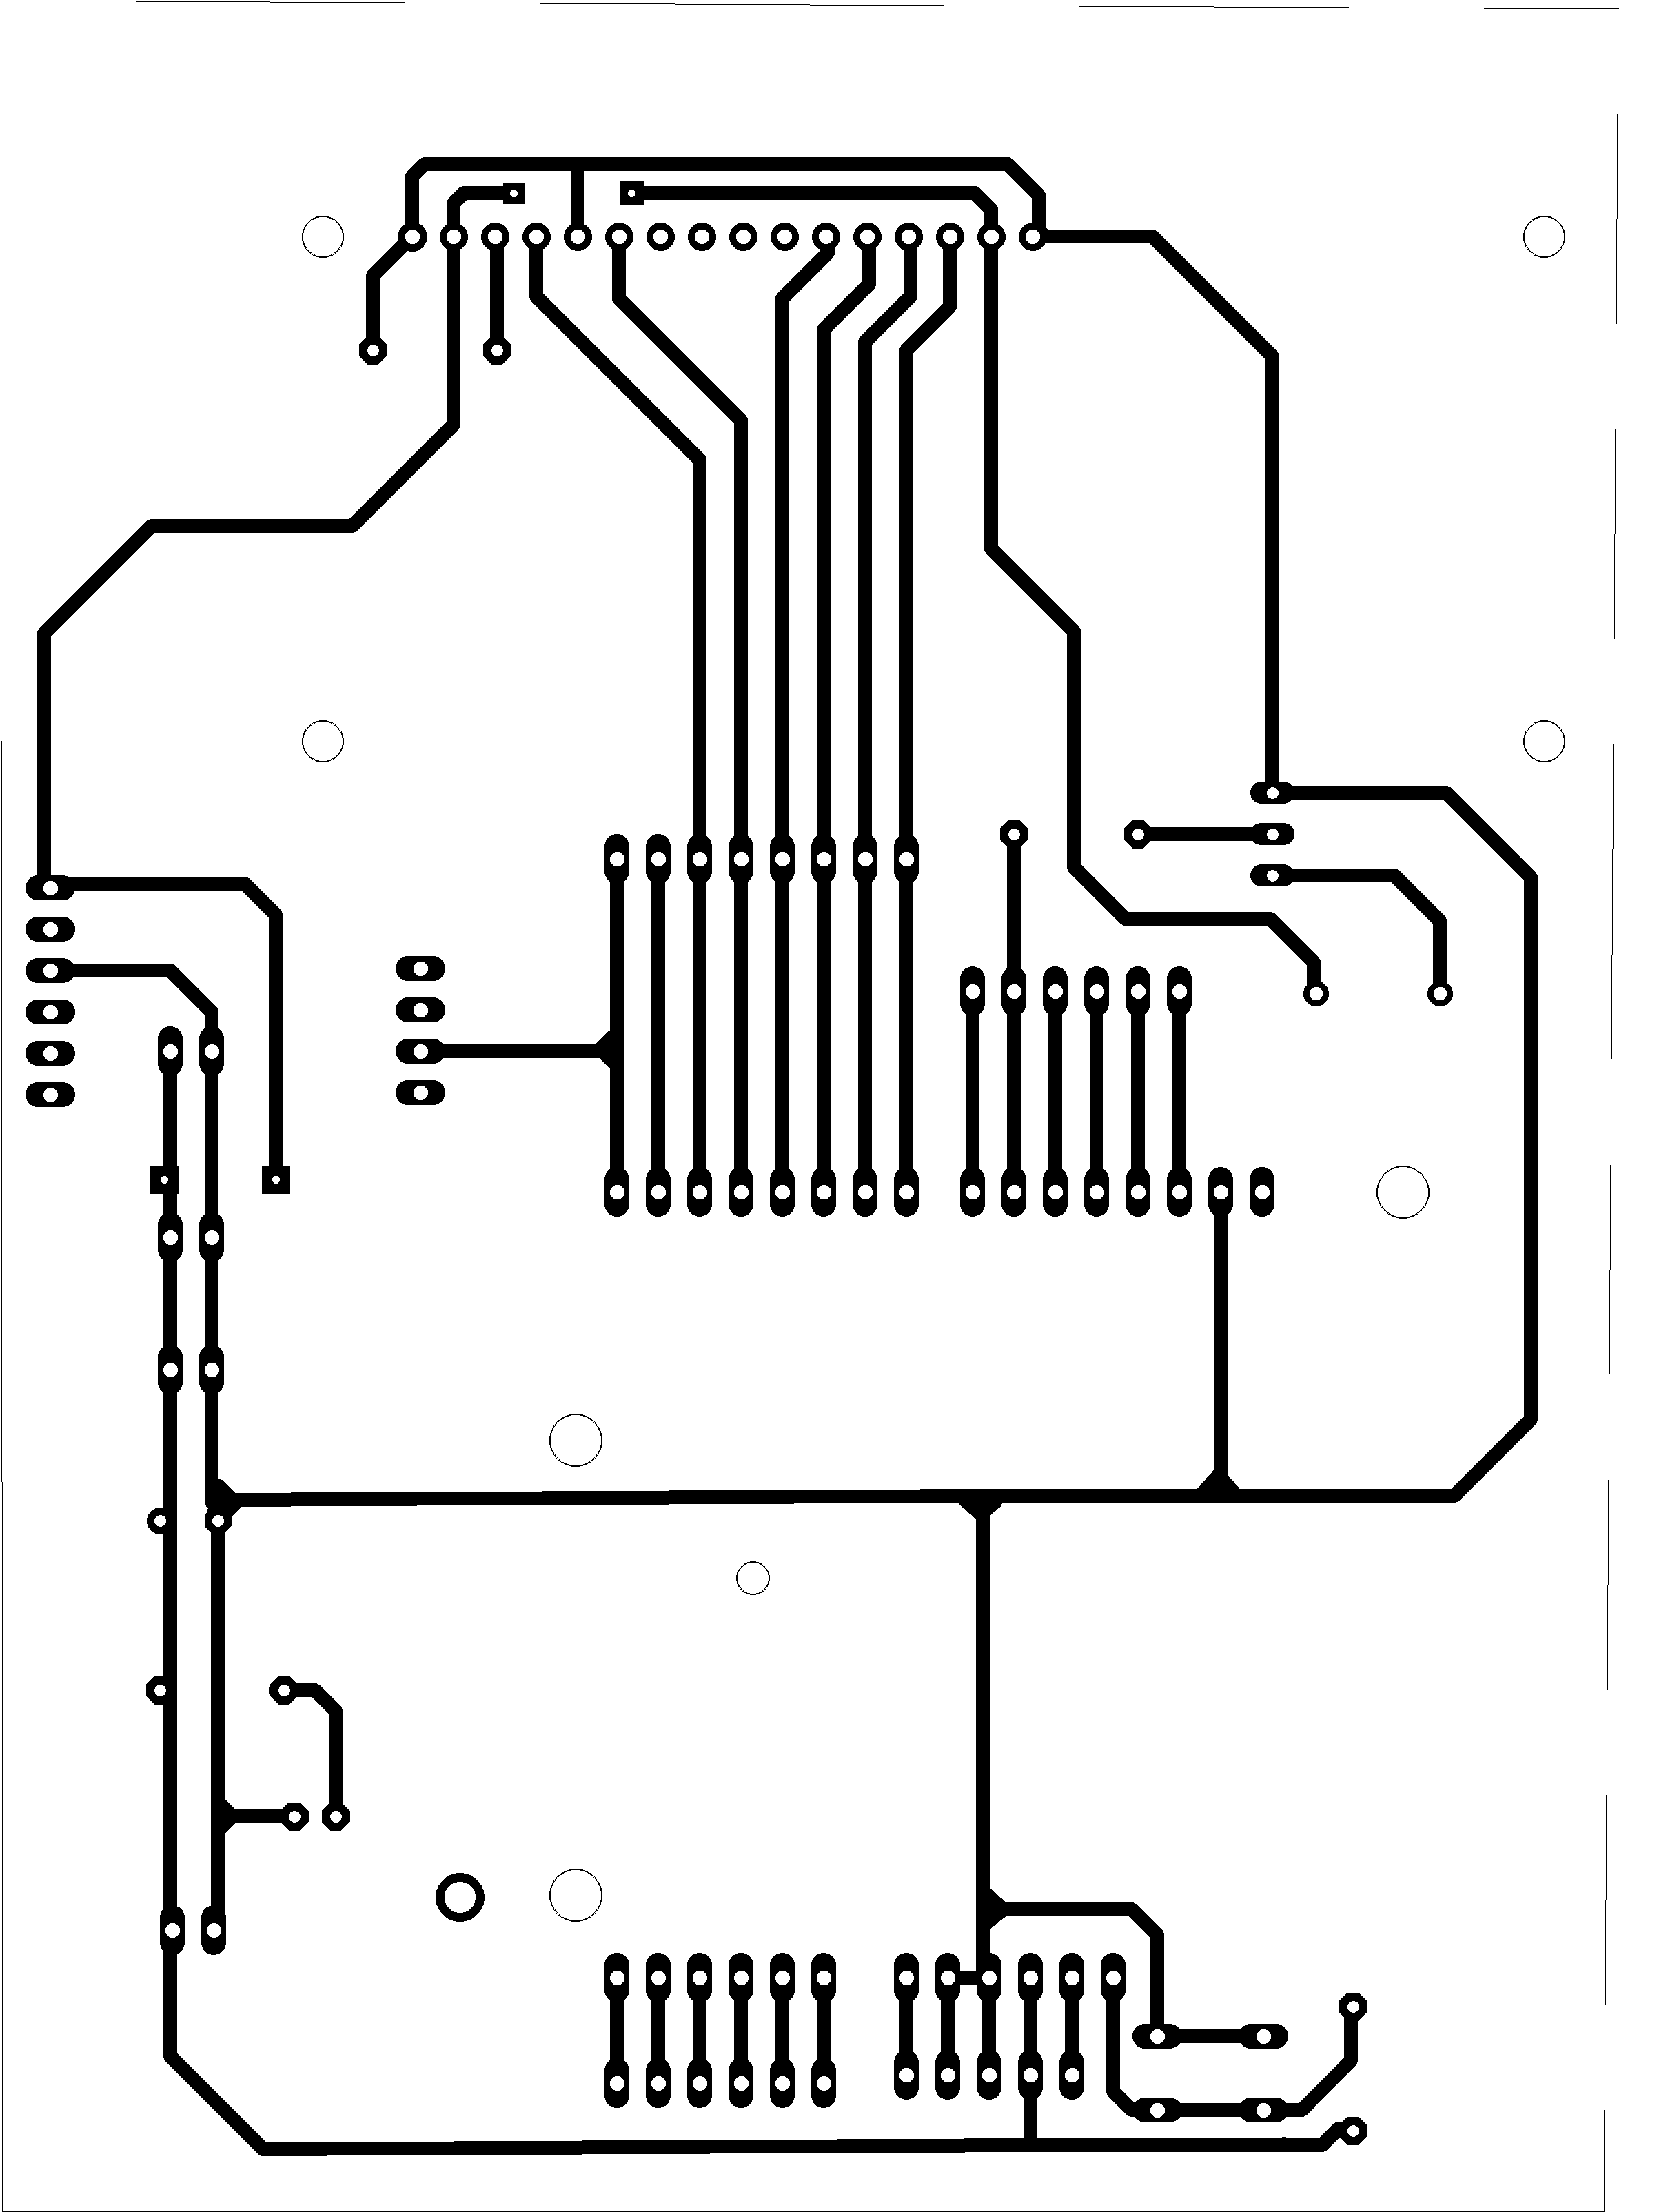

**9.Working**

1. All the items in the mall will be equipped with RFID cards. When person puts an item in the trolley, its card will be scanned by the RFID reader.

2. Reader send this code to Arduino Uno which further reads item’s name, cost & other details. Then it displays on LCD. The item details like name, price & total bill of things inserted in cart are displayed on liquid crystal display.

3. As we put the items, the costs will get added to total. Thus, the billing is done. Simultaneously all details are displayed on LCD. LCD used is 16x2 character alphanumeric type displays. And additionally if we would like to get rid of some inserted item, then that amount are mechanically subtracted from the entire amount and item removal message is displayed on LCD.

4. We are planning to use RFID tags which has one hundred twenty five kHz passive sort tags. Transponder (tag) is attached to the object. An RFID tag consists of a very small microchip and antenna. RFID tags will are available in a large style of sizes, shapes, and forms. Communication between the RFID Reader and tags happens wirelessly and usually doesn't need a line of sight between the devices. An RFID Reader can read through most anything. The RFID Reader emits a low-power radio emission field that is employed to power up the tag therefore to pass on any data that's contained on the chip.

5. LCD is interfaced with Arduino Uno. It is used to indicate clients the action taken by customer that's inserting of an item, removal of item, item’s value and total request value of things in the trolley. 6. At the billing Counter, the cashier counts the total number of items and collects cash and the total bill is provided to the customer.

**9.1 Code Used-**

/*

LiquidCrystal Library - Hello World

Demonstrates the use a 16x2 LCD display. The LiquidCrystal

library works with all LCD displays that are compatible with the

Hitachi HD44780 driver. There are many of them out there, and you

can usually tell them by the 16-pin interface.

This sketch prints "Hello World!" to the LCD

and shows the time.

The circuit:

* LCD RS pin to digital pin 12

* LCD Enable pin to digital pin 11

* LCD D4 pin to digital pin 5

* LCD D5 pin to digital pin 4

* LCD D6 pin to digital pin 3

* LCD D7 pin to digital pin 2

* LCD R/W pin to ground

* LCD VSS pin to ground

* LCD VCC pin to 5V

* 10K resistor:

* ends to +5V and ground

* wiper to LCD VO pin (pin 3)

Library originally added 18 Apr 2008

by David A. Mellis

library modified 5 Jul 2009

by Limor Fried (http://www.ladyada.net)

example added 9 Jul 2009

by Tom Igoe

modified 22 Nov 2010

by Tom Igoe

modified 7 Nov 2016

by Arturo Guadalupi

This example code is in the public domain.

http://www.arduino.cc/en/Tutorial/LiquidCrystalHelloWorld

*/

// include the library code:

#include <LiquidCrystal.h>

// initialize the library by associating any needed LCD interface pin

// with the arduino pin number it is connected to

const int rs = 2, en = 3, d4 = 4, d5 = 5, d6 = 6, d7 = 7;

LiquidCrystal lcd(rs, en, d4, d5, d6, d7);

int buzzer=9;

char card[13];

int i=0;

int total=0;

int in1=0;

int in2=0;

int in3=0;

int in4=0;

void setup() {

// set up the LCD's number of columns and rows:

lcd.begin(16, 2);

Serial.begin(9600);

// Print a message to the LCD.

lcd.print(" ANSHUL ");

lcd.setCursor(0,1);

lcd.print("WEL-COMES YOU");

pinMode(9,OUTPUT);

delay(2000);

lcd.clear();

}

void loop() {

if(Serial.available()>0)

{

delay(12);

digitalWrite(buzzer,1);

i=0;

while(Serial.available()>0)

{

card[i]=Serial.read();

i++;

delay(1);

}

Serial.println(card);

lcd.setCursor(0,0);

digitalWrite(buzzer,0);

if(strncmp(card,"5300B7EACDC3",11)==0)//86007305CD3D 86007598C3A8 860075987C17

{

Serial.print("match1");

if(in1==0)

{

in1=1;

lcd.print("Cinthole IN=99/- ");

total=total+99;

}

else

{

in1=0;

lcd.print("Cinthole OUT=99/- ");

total=total-99;

}

}

if(strncmp(card,"86007305CD3D",11)==0)//86007305CD3D 86007598C3A8 860075987C17

{

Serial.print("match1");

if(in2==0)

{

in2=2;

lcd.print("Lux IN= 15/- ");

total=total+15;

}

else

{

in2=0;

lcd.print("Lux OUT= 15/- ");

total=total-15;

}

}

if(strncmp(card,"86007598C3A8",11)==0)//86007305CD3D 86007598C3A8 860075987C17

{

Serial.print("match1");

if(in3==0)

{

in3=2;

lcd.print("Senitizer IN=49/- ");

total=total+49;

}

else

{

in3=0;

lcd.print("Senitizer OUT=49/- ");

total=total-49;

}

}

if(strncmp(card,"860075987C17",11)==0)//86007305CD3D 86007598C3A8 860075987C17

{

Serial.print("match1");

if(in4==0)

{

in4=2;

lcd.print("Mask IN=50/- ");

total=total+50;

}

else

{

in4=0;

lcd.print("Mask OUT=50/- ");

total=total-50;

}

}

while(Serial.available()>0)

{

Serial.read();

}

delay(2000);

}

lcd.setCursor(0,1);

lcd.print("Total=");

lcd.print(total);

lcd.print("/- ");

}

**10.Future Scope**

Depending on the RFID reader used, it could read around 7 tags in a second. And the major task of avoiding the reading of the same tag multiple times has also been accomplished by implementing a quiet tag function. Finally the billing is completed in nearly one tenth of the time required in barcode based billing system including the time required in dispatching the items which include removing of tags from the items. Further, in future we can look forward to implementing it in shopping malls using a long range RFID reader (with a range of ~2metres).

1. The utility of trolley are 1st of its kind for industrial use.

2. This device records the information of the various product with facilitate of the acceptable sensors like RFID Tags.

3. This recorded information helps the search owner with careful analysis of shopping by the client & their preferences through the computer; output signal of a similar may be obtained.

4. Net banking can be included.

5. Using a GSM module we are able to transfer the bill to mobile rather than printing it.

6. Voice assistance can be included.

7. Robotic ARM may be used for selecting and dropping of product

**11.Conclusion**

By means of this paper we tend to intent to modify the billing process, build it swift & increase the protection using RFID technique. The cart has the feature calculate mechanically and show the entire costs of all the product within it. This makes it simple for the client to understand what amount he or she has got to pay during shopping and not at the checkout. One can delete the product from the cart by just scanning it again if he or she does not want it. The system proposed is highly dependable, authentic, trustworthy and time-effective. There will be reduction in wage amount given to workers, reduction in theft. Also, the system is very time-efficient. This will take the looking expertise to a special level. Different parameters such as the system parameters of smart trolley like products name and products cost are continuously display.